**CIND 119: Introduction to Big Data Analytics**

**Assignment 3 (15% of the final grade)**

**Querying a NoSQL database using MongoDB**

1. Create a database called “sample”. (1 point)

2. Create a collection called “test_data” and load the following data into the collection. (6 points)

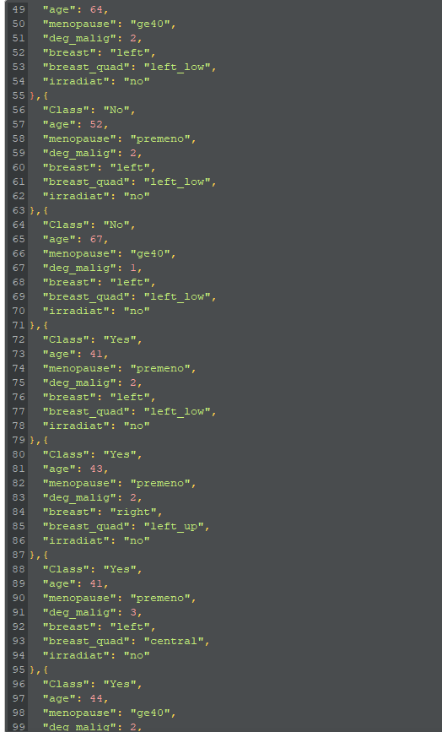

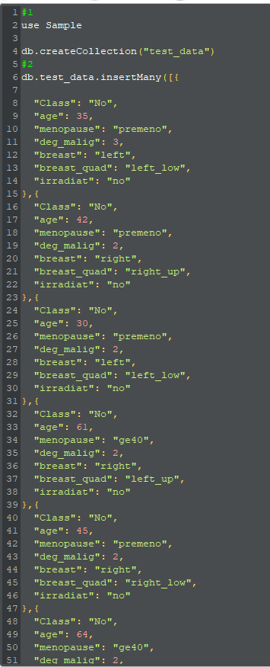

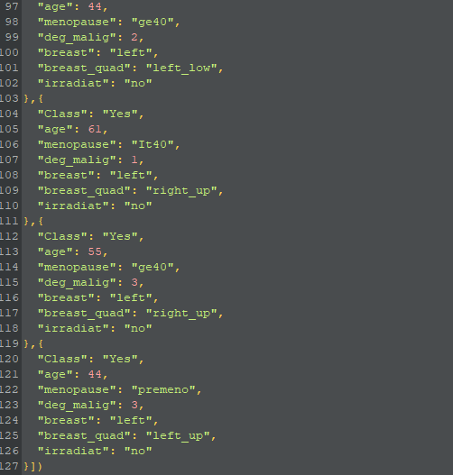

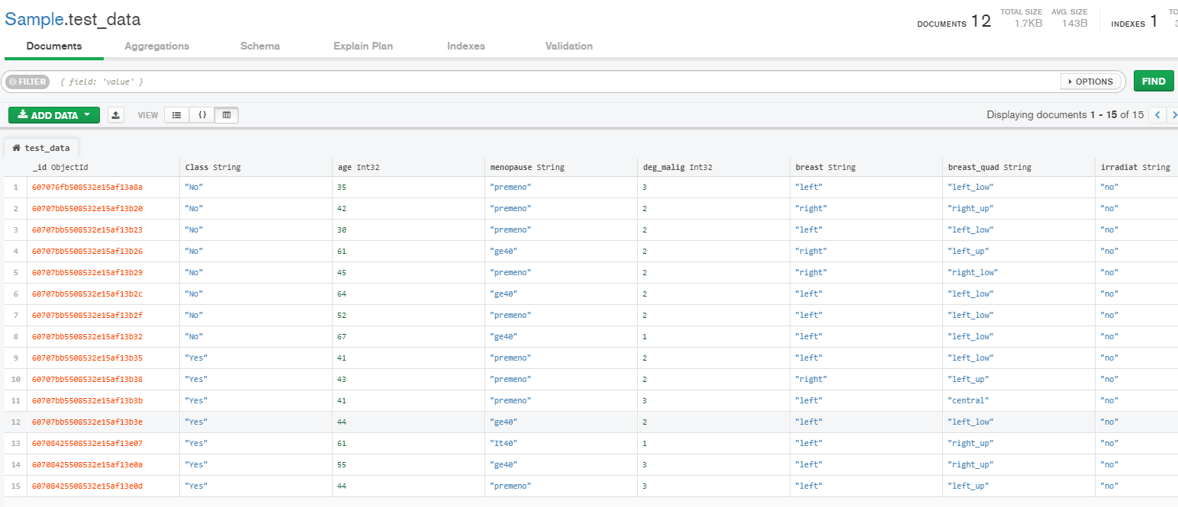

* 1. 3. Write MongoDB queries to select/compute data from the “test_data” collection. (2 points each)
  2. a. Select all rows where the menopause column has the value “ge40”.

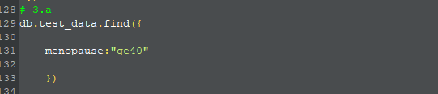

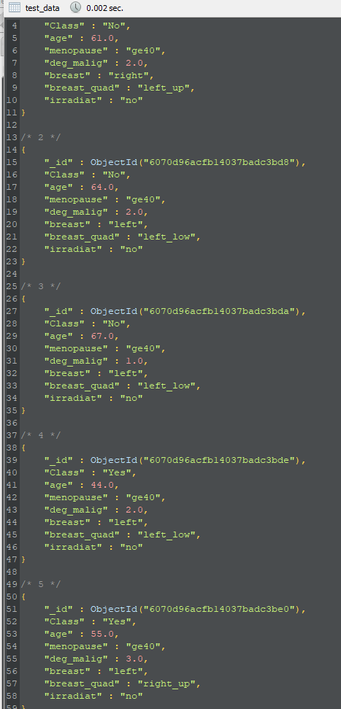

* 1. b. Select all rows where age is less than 41.

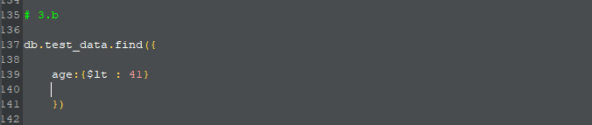

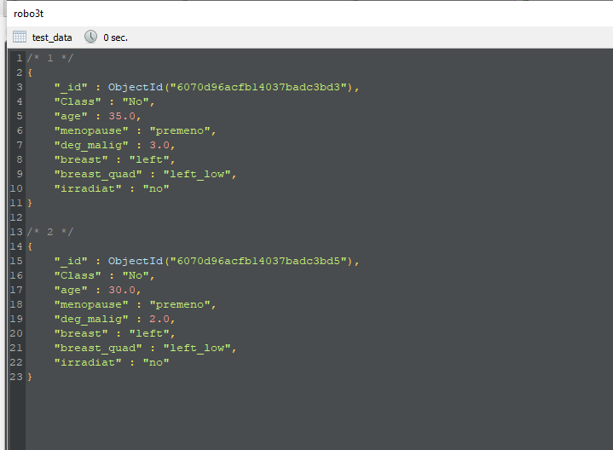

* 1. c. Select all rows where age is less than 41 or the menopause column has the value “ge40”.

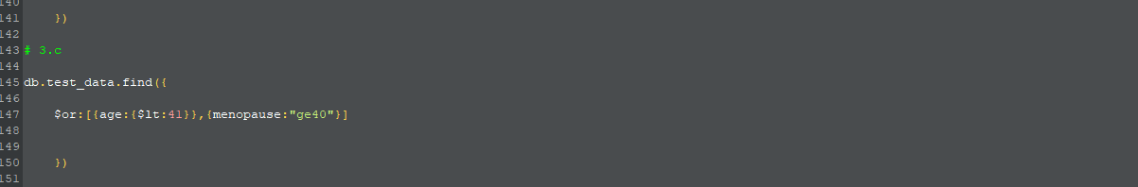

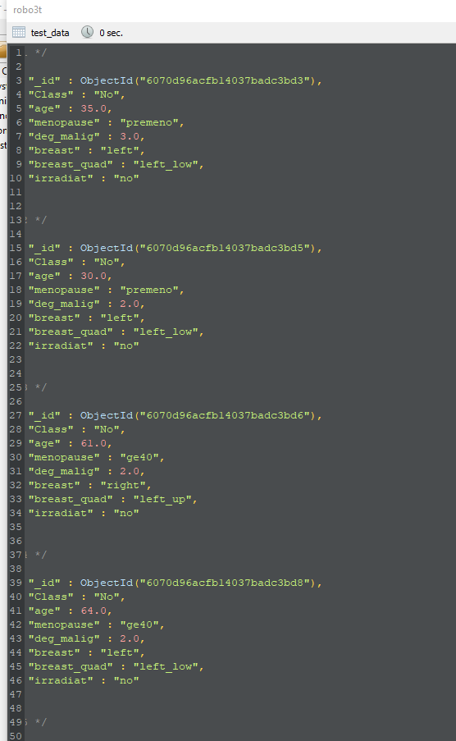

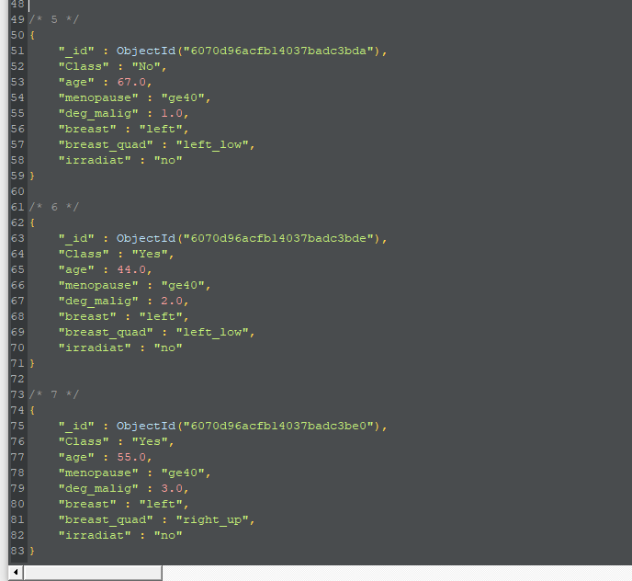

* 1. d. Compute the average age across all rows.

